A&P Review for Nursing students
The Cardiac System Worksheet 2: Cardiac Physiology

The worksheet below is adapted from

  - Fundamentals of Anatomy and Physiology (9th Ed) by Martinin at al

  - Human Anatomy and Physiology Lab Manual (9th Ed) by Marieb and Mitchell

- What are the 2 types of cardiac muscle cells involved in a normal heartbeat?

_____________________________________________________________________________

_____________________________________________________________________________

_____________________________________________________________________________

- What does the term ‘autorhythmicity’?

_____________________________________________________________________________

_____________________________________________________________________________

_____________________________________________________________________________

- Match the terms on the left with the numbers in the figure for the components of the conducting system in the heart.

    - Bundle branches

    - Internodal pathways

    - Atrioventricular (AV) bundle

    - Sinoatrial (SA) node

    - Purkinje fibers

    - AV bundle (bundle of His)
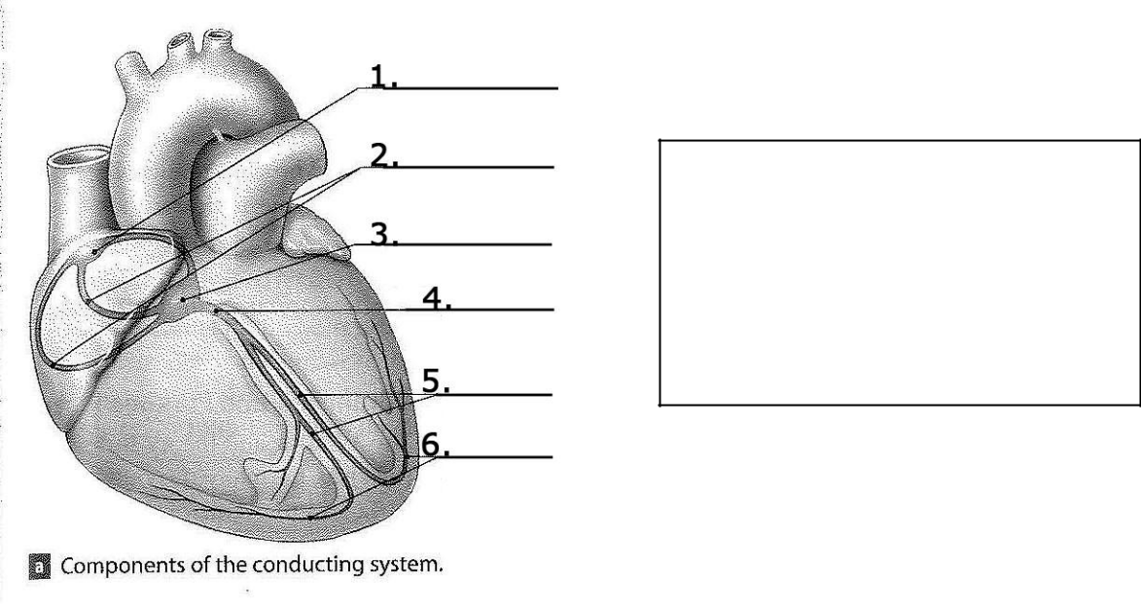

4. Referring to the graph below, describe the pacemaker potential.
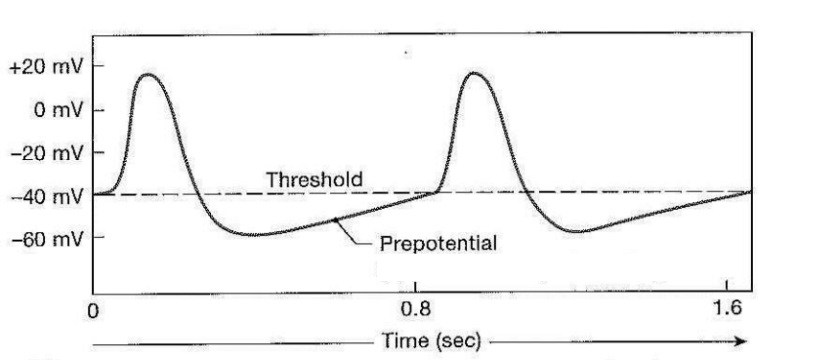

1
Developed by The Learning Commons at Tallahassee Community College

A&P Review for Nursing students
The Cardiac System Worksheet 2: Cardiac Physiology

_____________________________________________________________________________

_____________________________________________________________________________

_____________________________________________________________________________

- Describe the pathway for impulse conduction through the heart; you may use the diagram below to indicate the pathway.

______________________________________________________________________________

______________________________________________________________________________

______________________________________________________________________________

______________________________________________________________________________

______________________________________________________________________________

______________________________________________________________________
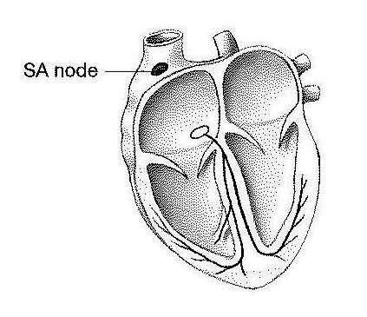

2
Developed by The Learning Commons at Tallahassee Community College

A&P Review for Nursing students
The Cardiac System Worksheet 2: Cardiac Physiology

- What is an electrocardiogram (ECG or EKG)?

_____________________________________________________________________________

_____________________________________________________________________________

_____________________________________________________________________________

- Describe the events depicted on the cardiogram:
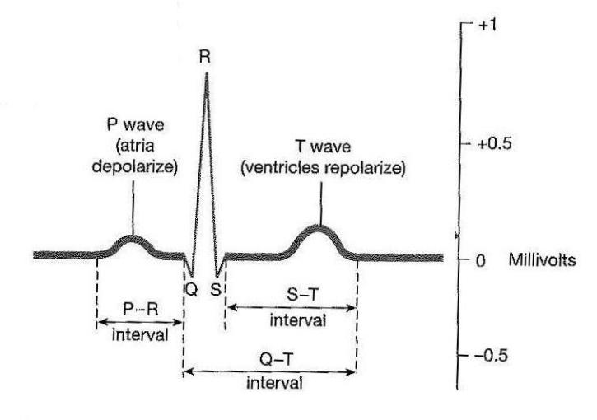

______________________________________________________________________________

______________________________________________________________________________

___________________________________________________________________________

8. Describe the phases of the Cardiac Cycle.

3
Developed by The Learning Commons at Tallahassee Community College

