Circular Motion

Centripetal Force

Centripetal force is a force that makes an object follow a curved path: it always directs orthogonally to the velocity of the object, toward the instantaneous center of the curvature of the path.

T= $\frac{2πR}{v}$ $T= \frac{2πv}{a}$ a= $\frac{V^{2}}{R}$ $F_{Centripetal }=m$ a = m $\frac{V^{2}}{R}$



Vertical Circular Motion

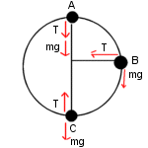

For object at the top (A), $F_{Centripetal }$ = m $\frac{V^{2}}{R}$ =mg + $T_{top}$

For object at the bottom (C), $F_{Centripetal }$ = m $\frac{V^{2}}{R}$ = $T_{bottom}$- mg

Horizontal Circular Motion

Examples of circular motion include:

*An artificial satellite orbiting the Earth at a constant height

$F_{Centripetal }$ = $\frac{GMm}{R^{2}}$ = m $\frac{V^{2}}{R}$

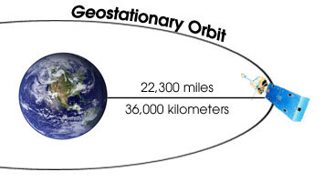

M is the earth’s mass =6.0 x ${10}^{24}$ kg G=

*A stone that is tied to a rope and is being swung in circles

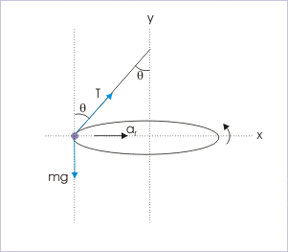

T cos(θ)= mg

T sin(θ) = $F_{Centripetal }$ = m $\frac{V^{2}}{R}$

*A car turning through a curve in a [race track](https://en.wikipedia.org/wiki/Race_track)

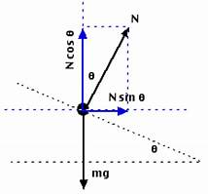

N sin(θ) =mg

N sin(θ) = $F_{Centripetal }$ = m $\frac{V^{2}}{R}$

*An electron moving perpendicular to a uniform [magnetic field](https://en.wikipedia.org/wiki/Magnetic_field)

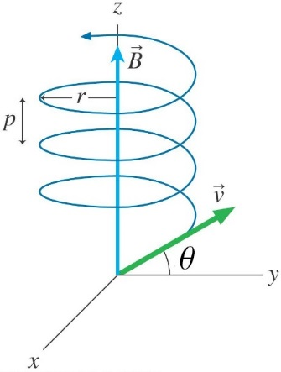

$V_{normal to B}$ = V cos( $θ)$ $V_{paralel to B}$ = V sin($θ)$

$F_{Centripetal }$ = q V cos( $θ)$ x B =m $\frac{{(Vcos\left(θ\right) )}^{2}}{R}$

R = $\frac{qV cos(θ)}{B}$

Pitch = V sin( $θ)$ x T = V sin( $θ)$ X $\frac{2πR}{ V cos(θ) }= 2πR tan(θ)$

*Bohr Model

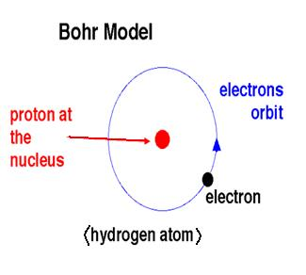

$F_{Centripetal }$ = k $\frac{q^{2}}{r^{2}}$ = m $\frac{V^{2}}{R}$

Mass of electron = 9 x ${10}^{-31 } kg$