How to order business cards through the Office Depot punchout

- Log in to Workday

- Click on the REQUISITIONS app

- Select CONNECT TO SUPPLIER WEBSITE

- Connect to the ODP Business Solutions website

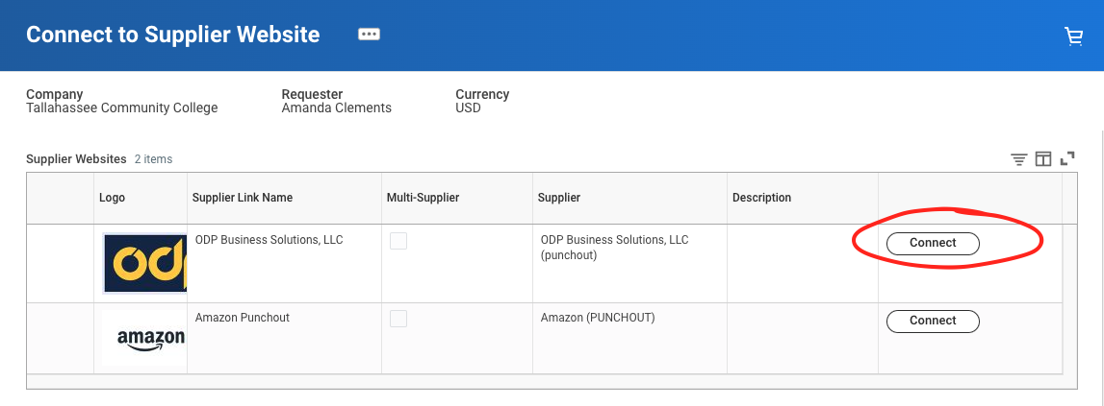

- Click on the PRODUCTS menu in the top left of the screen

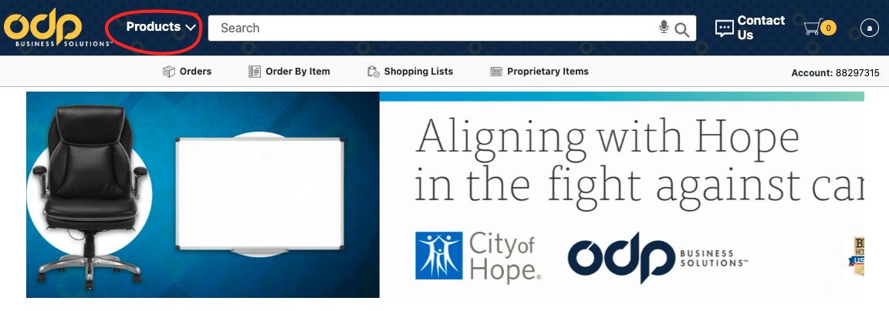

- Hover your mouse over PRINT & COPY, then select SEE ALL PRINT & COPY SERVICES
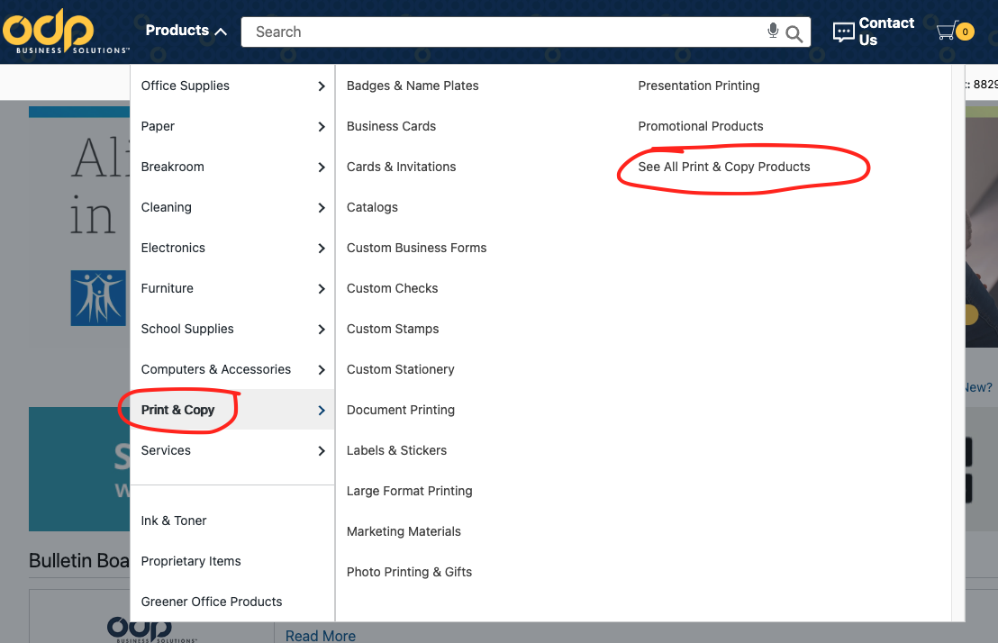

- Select BRAND IDENTITY

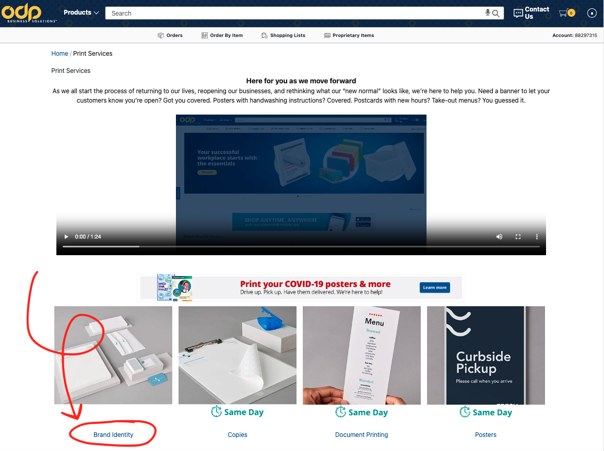

- Select the template and click CREATE

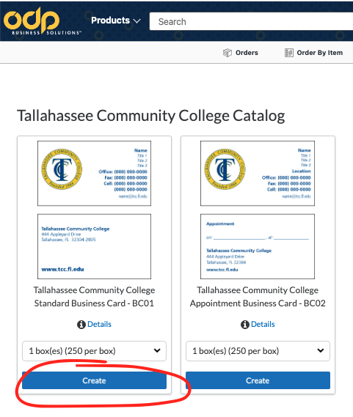

- Enter your information, check your proof, and click NEXT

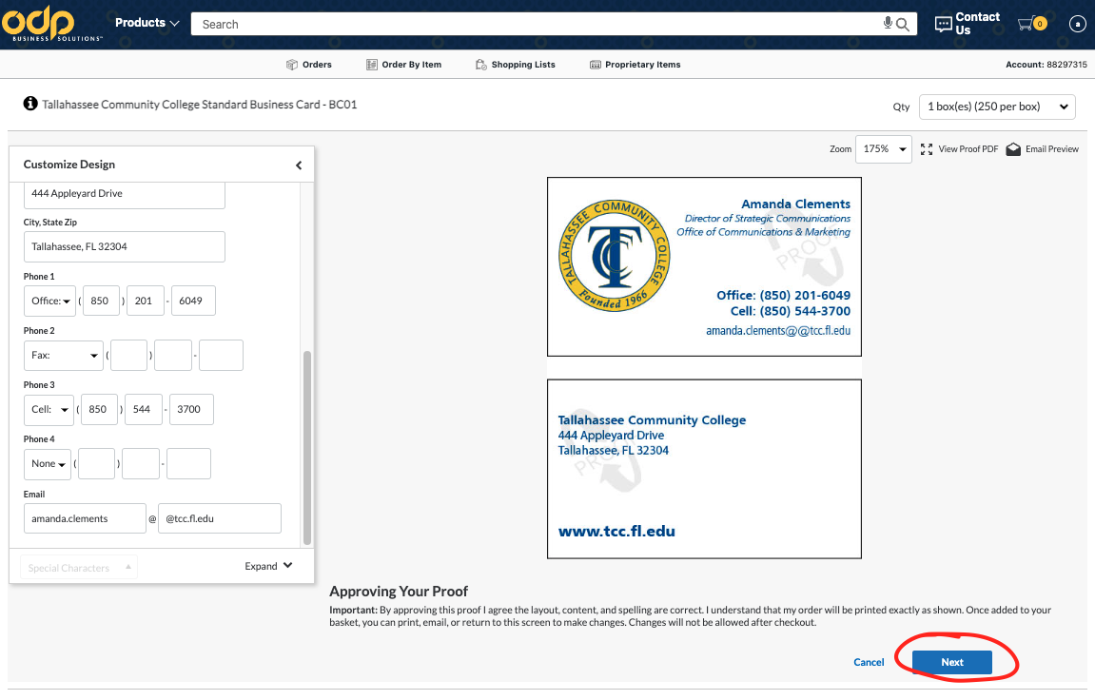

- Check your cart and click NEXT

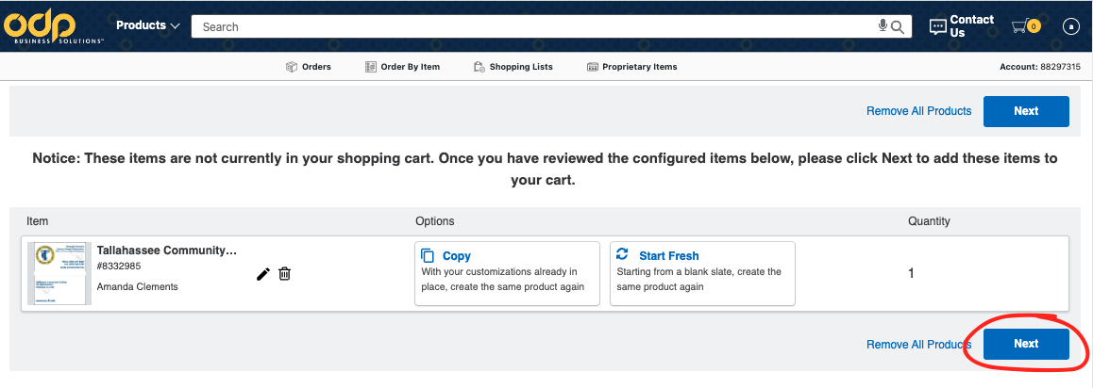

- Click CHECKOUT and follow the prompts

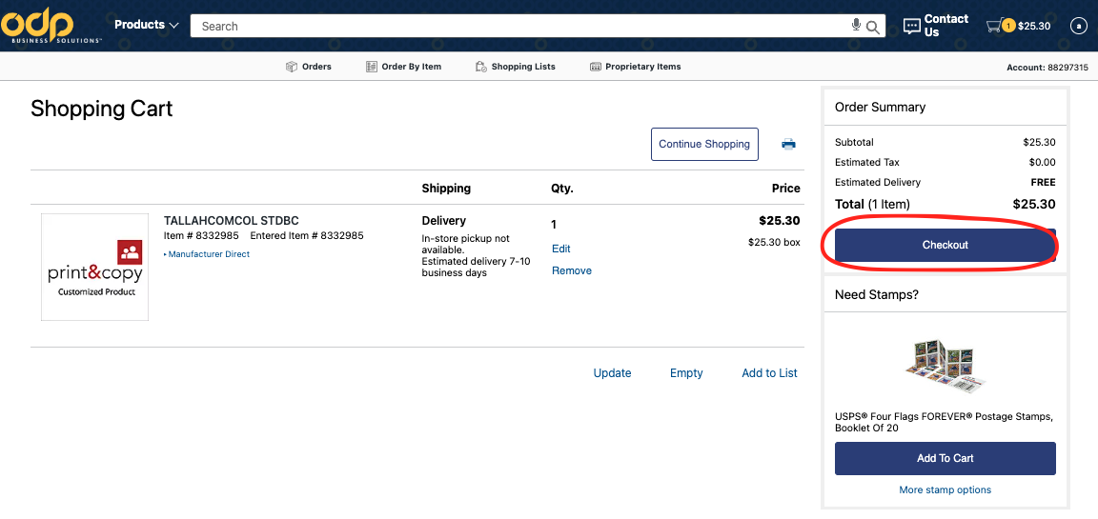

- Will now take you back to Workday to complete the Requisition process

