Vocabulary
Displacement (ΔX): This is the difference between the initial and final position of an object.
Ex: If you travel to school from your home, and then return home.
- Your displacement is calculated by your final position (home) minus your initial position (home).
- The standard unit for displacement is in meters (m).
- Since the final and initial positions are the same, your displacement is zero (0m).
- Displacement is strictly based on a position at a given period of time.
Average Velocity: This deals with the displacement over a period of time.
0 m/s
t

ΔX
time

Xf – xi
time

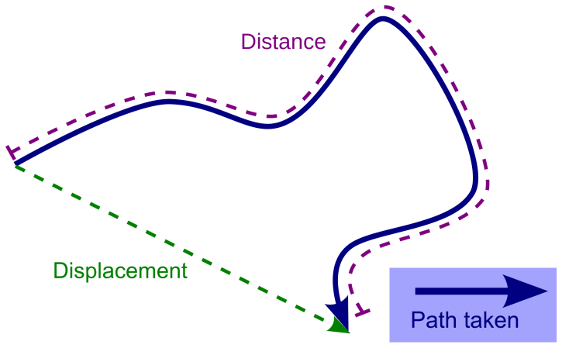
Distance Traveled (S): This is the total amount of distance that was actually traveled following a given path for a specific time interval.
Ex: Let’s say that it took you 700s from the time that you left home to the time that you returned home from school.
- Over that given period of time you may have made several stops (restaurant, run errands, went to school, hang out with friends, went back home).
- Those particular stops occurred at various time intervals, and required a specific amount of distance to be traveled in order to reach them.
- The total distance traveled from the time you left your home until the time you returned to your home was approximately 350m.
- Distance traveled is strictly based on how much you actually traveled over a given period of time.
Average Speed: This deals with the actual distance traveled over a period of time.
0.5 m/s
t

S
time

Distance
time

